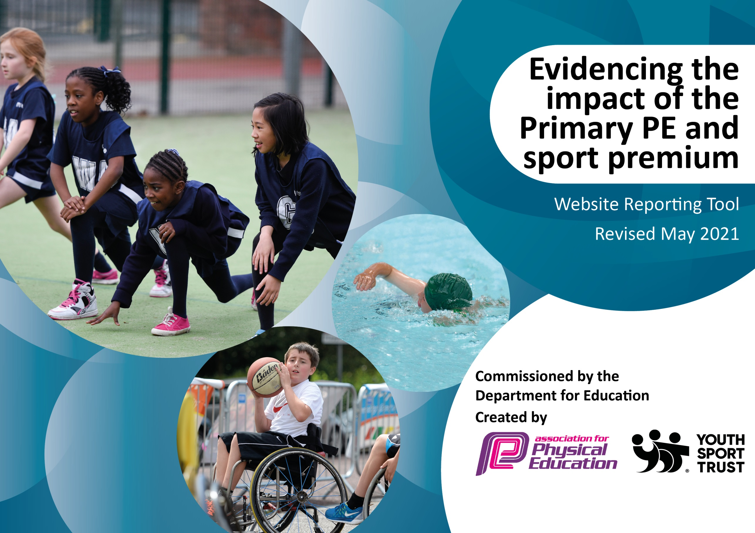

It is important that your grant is used effectively and based on school need. The Education Inspection Framework (Ofsted 2019 p64) makes clear there will be a focus on **‘whether leaders and those responsible for governors all understand their respective roles and perform these in a way that enhances the effectiveness of the school’**.

Under the Quality of Education criteria (p41) inspectors consider the extent to which schools can articulate their curriculum (INTENT), construct their curriculum (IMPLEMENTATION) and demonstrate the outcomes which result (IMPACT).

To assist schools with common transferable language this template has been developed to utilise the same three headings which should make your plans easily transferable between working documents.

Schools must use the funding to make **additional and sustainable** improvements to the quality of Physical Education, School Sport and Physical Activity (PESSPA) they offer. This means that you should use the Primary PE and sport premium to:

* Develop or add to the PESSPA activities that your school already offer
* Build capacity and capability within the school to ensure that improvements made now will benefit pupils joining the school in future years
* The Primary PE and sport premium should not be used to fund capital spend projects; the school’s budget should fund these.

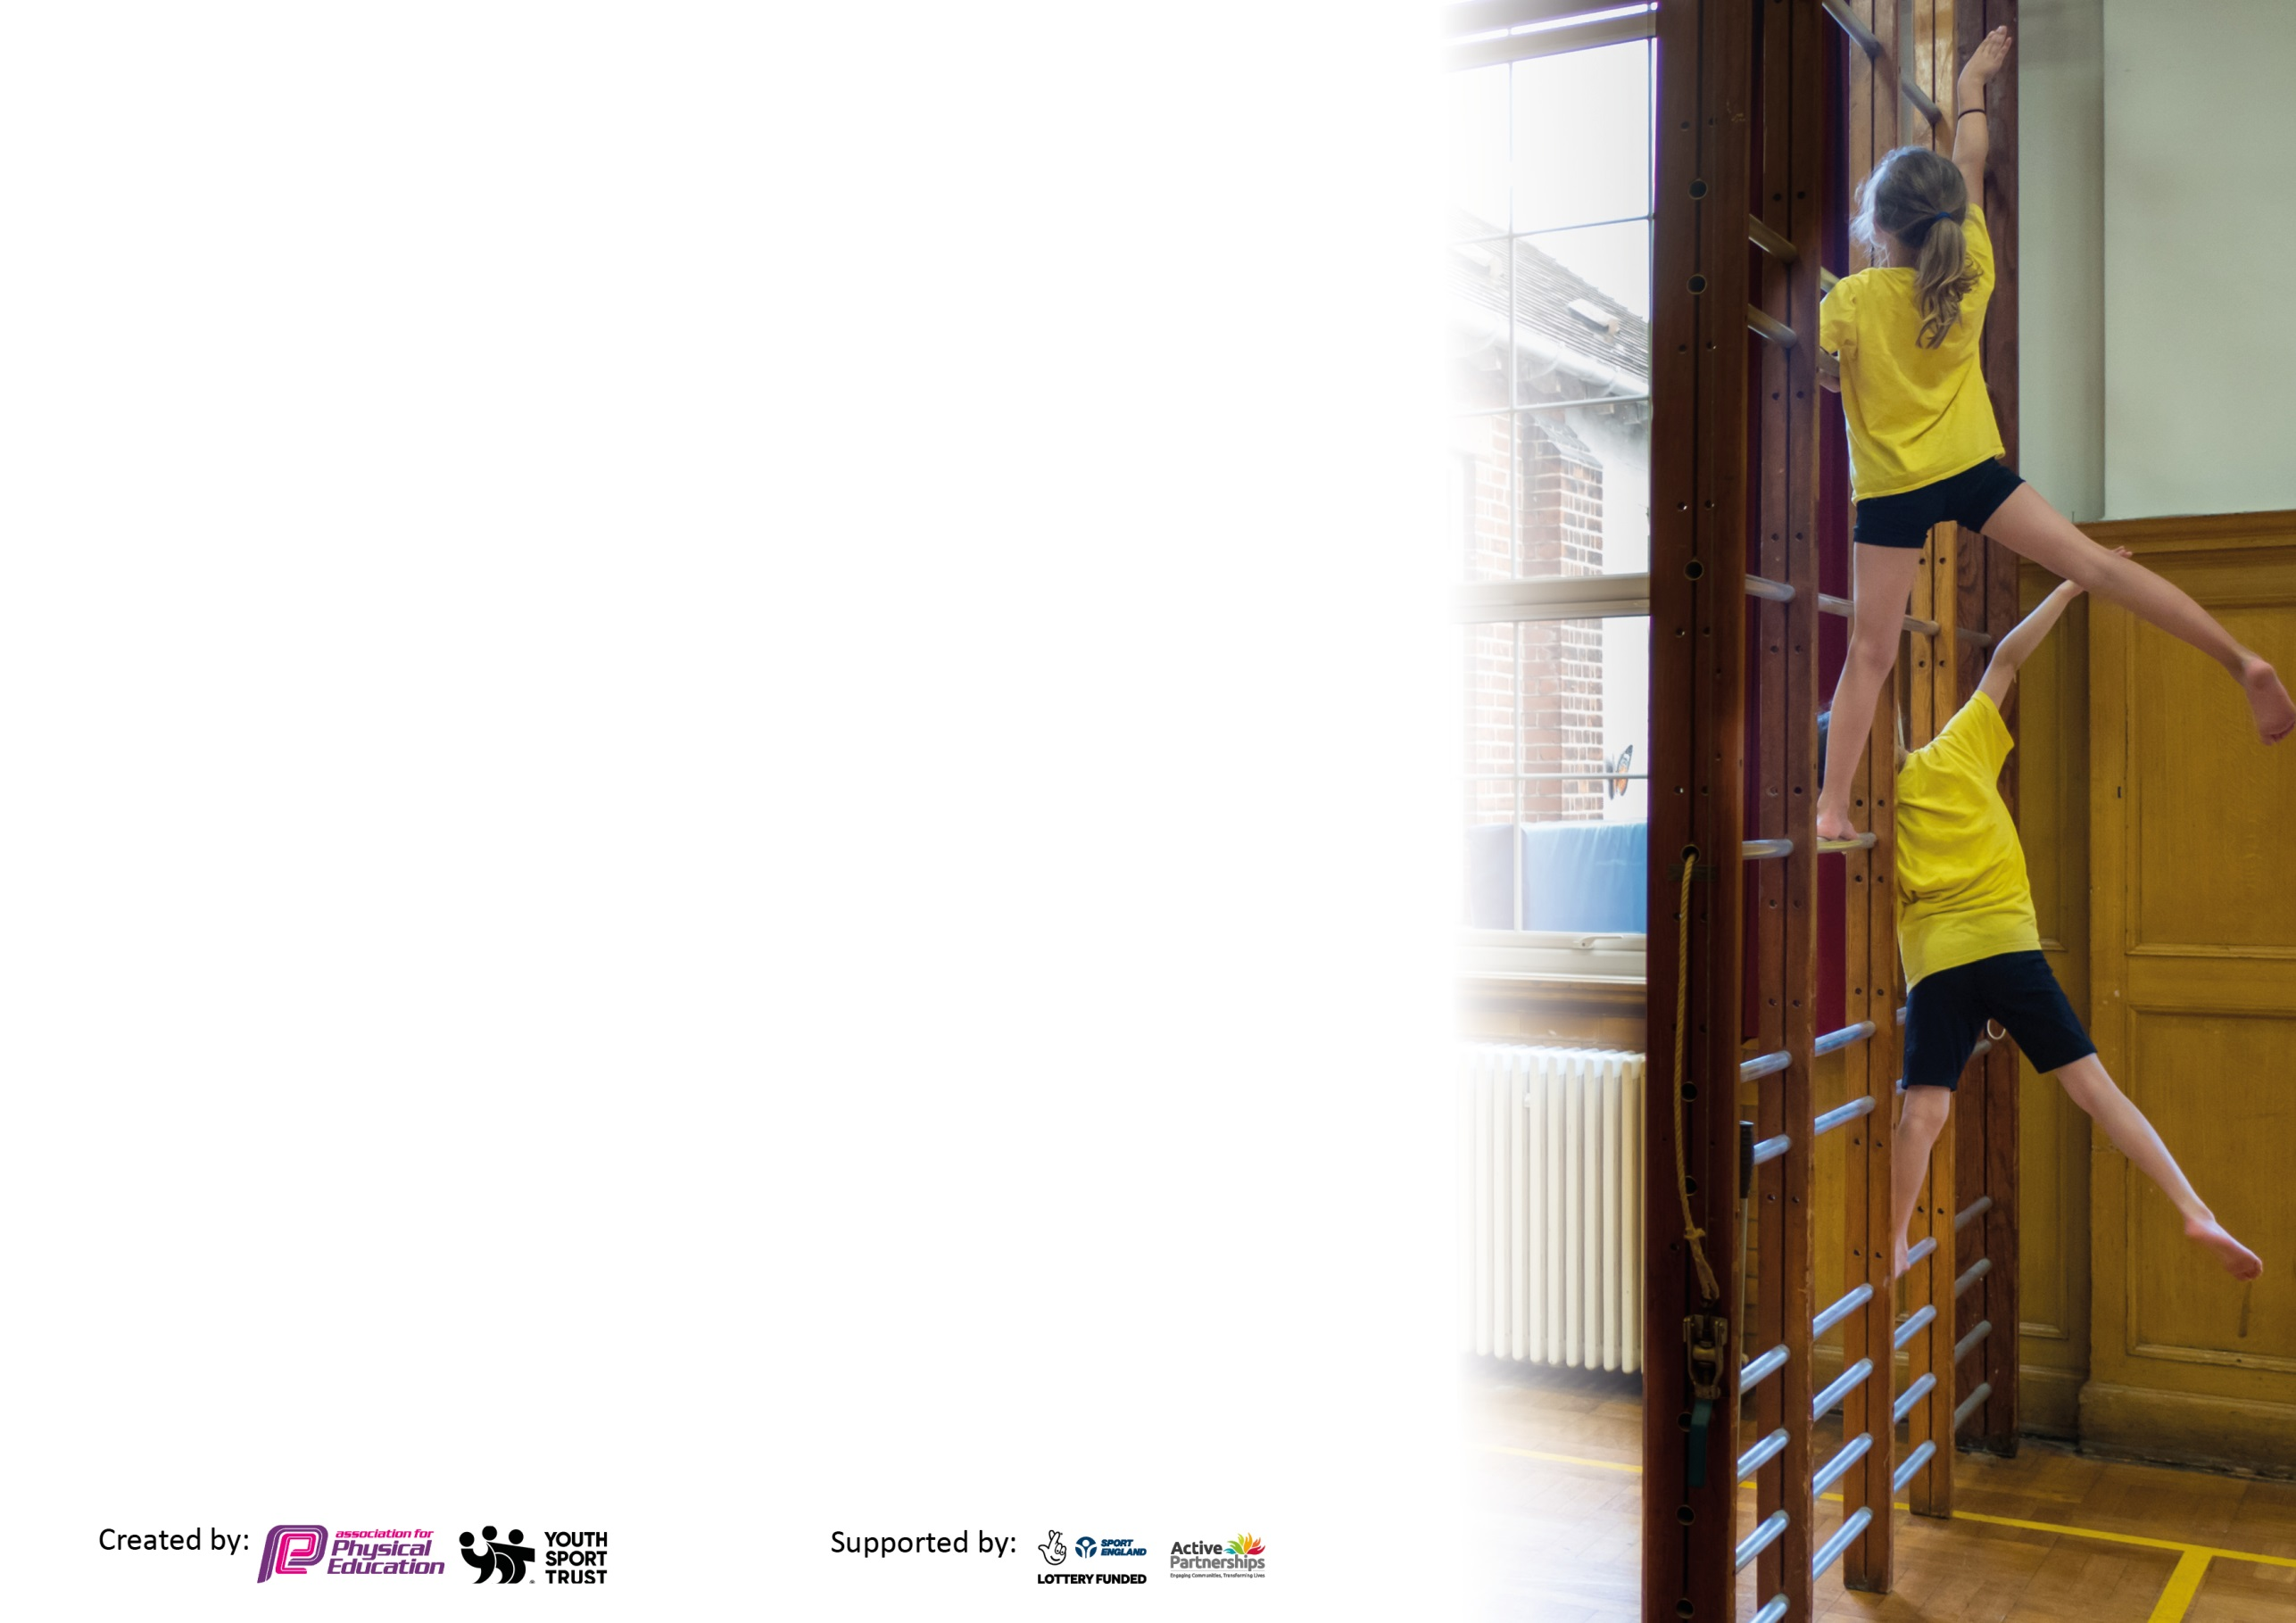

Please visit gov.uk for the revised DfE guidance including the 5 key indicators across which schools should demonstrate an improvement. This document will help you to review your provision and to report your spend. DfE encourages schools to use this template as an effective way of meeting the reporting requirements of the Primary PE and sport premium.

We recommend you start by reflecting on the impact of current provision and reviewing the previous spend.

Schools are required to publish details of how they spend this funding, including any under-spend from 2019/2020, as well as on the impact it has on pupils’ PE and sport participation and attainment by the end of the summer term or by **31st July 2021** at the latest.

We recommend regularly updating the table and publishing it on your website throughout the year. This evidences your ongoing self-evaluation of how you are using the funding to secure maximum, sustainable impact. Final copy must be posted on your website by the end of the academic year and no later than the 31st July 2021. To see an example of how to complete the table please click HERE.



N.B. In this section you should refer to any adjustments you might have made due to Covid-19 and how these will influence further improvement.

Support for review and reflection - considering the 5 key indicators from DfE, what development needs are a priority for your setting and your pupils now and why? Use the space below to reflect on previous spend and key achievements and areas for development.

|  |  |
| --- | --- |
| Key achievements to date until July 2021: | Areas for further improvement and baseline evidence of need: |
| Provided swimming for 2 year groups across key stage 1 and 2.  Hosted sports days for each year group.  Competed in Covid safe competitions within school sports partnership.  Arranged our own competitions (inter school) for several sports.  Set PE challenges during lockdowns to engage children at home.  Initiated a daily mile run outside of the school perimeter for both staff and pupils.  Run multiple sports ASC.  Get Fit for Summer campaign which included lunch time running clubs, boot camp sessions, daily runs and the return of clubs post Covid.  Provided a healthy lifestyles week.  Taught 3 PE sessions a week post lockdown.  Maintained a range of sports despite covid19 restrictions. | Provide progressive unit overviews to ensure staff confidence with the skills being taught.  Continue to develop links within our school’s partnership and other schools. |

Did you carry forward an underspend from 2019-20 academic year into the current academic year? YES/NO * Delete as applicable

**+ Total amount for this academic year 2020/2021 £19610.00**

**= Total to be spent by 31st July 2021 £19610.00**

|  |  |
| --- | --- |
| Meeting national curriculum requirements for swimming and water safety.  N.B Complete this section to your best ability. For example, you might have practised safe self-rescue techniques on dry land which you can transfer to the pool when school swimming restarts.  **Due to exceptional circumstances priority should be given to ensuring that pupils can perform safe self-rescue even**  **if they do not fully meet the first two requirements of the NC programme of study.** |  |
| What percentage of your current Year 6 cohort swim competently, confidently and proficiently over a distance of at least 25 metres?  **N.B.** Even though your pupils may swim in another year please report on their attainment on leaving primary school at the end of the summer term 2021.  Please see note above. | 93% able to swim 10m  90% able to swim 25m |
| What percentage of your current Year 6 cohort use a range of strokes effectively [for example, front crawl, backstroke and breaststroke]?  Please see note above. | 90% |
| **What percentage of your current Year 6 cohort perform safe self-rescue in different water-based situations?** | 93% |
| Schools can choose to use the Primary PE and sport premium to provide additional provision for swimming, but this must be for activity **over and above** the national curriculum requirements. Have you used it in this way? | Yes |

**Action Plan and Budget Tracking**

Capture your intended annual spend against the 5 key indicators. Clarify the success criteria and evidence of impact that you intend to measure to evaluate for pupils today and for the future.

|  |  |  |  |  |
| --- | --- | --- | --- | --- |
| **Academic Year:** 2020/21 | **Total fund allocated:** £ | **Date Updated:** | |  |
| **Key indicator 1:** The engagement of all pupils in regular physical activity – Chief Medical Officers guidelines recommend that primary school pupils undertake at least 30 minutes of physical activity a day in school | | | | Percentage of total allocation: |
| % |
| **Intent** | **Implementation** | | **Impact** |  |
| Your school focus should be clear what you want the pupils to know and be able to do and about  what they need to learn and to  consolidate through practice: | Make sure your actions to achieve are linked to your intentions: | Funding allocated: | Evidence of impact: what do pupils now know and what can they now do? What has changed? | Sustainability and suggested next steps: |
| To increase the engagement of pupils in physical activity daily, during lunch time, break times and afterschool in a variety of different sports.  To know that physical activity can be applied in different contexts and know the importance of leading a healthy lifestyle (balanced diet, physical exercise and mental wellbeing.) | Introduce a daily run around the perimeter of the school Monday-Thursday.  Lunchtime running club led by VK and LW.  Bootcamp sessions led for KS2.  TA training on get fit for summer programme where active play activities were shared.  ASC – Football, Netball, Multi Sports, Dodgeball, Hockey, Rugby.  SSA’s to support SEND pupils during PE.  Provide 3 hours of taught PE sessions.  Sports coach deliver competitive training specific to competitions.  PE challenges set during covid19 lockdown to engage and motivate pupils in physical activity whilst studying from home.  Scoot, cycles or walk to school week.  Healthy lifestyles week.  Get Fit for Summer campaign including lunch time running clubs, boot camp sessions, daily runs, 3 PE sessions a week and the return of clubs post Covid.  Smoothie bike workshops.  Mental Wellbeing (Calm Project) week post Covid. | £1312.00  £245.52  £240.63  £491.04  £6186.18 | Children run Monday-Thursday around the perimeter of the school.  Children seem more active outside of school with children encouraging their families to do the running route either on foot, bike or scooter.  Increase in demand to attend running clubs.  Children’s can maintain physical activities for longer periods of time.  Children demonstrate a knowledge and understanding on why physical activity is important for a healthy lifestyle and understand that physical activity comes in many forms.  TAs led active playtimes on a weekly basis developing social skills and physical activity.  ASC are both for participation and training for competitions 156  Attention was put on physical activity after missing out on break times and lunch times during covid19 and not being able to develop the social skills that physical activity often offers.  Children enjoyed being exposed to local clubs and engaging in a mental and physical stimulating sport which is not usually offered in school.  Increased awareness of the importance of physical activity and leading a healthy life.  Children have appreciated the mental health benefits that completing physical activities have (e.g. KS2 talking about endorphins KS1/EYFS understanding that exercise can make me feel better)  All parents believe that their child receives 60 minutes of physical activity while at school. | Daily run is to continue next academic year.  Explore the opportunities for wider school community involvement in engaging pupils in developing the amount of physical activity the do daily.  Up level staff as Change4Life champion.  Explore the range of ASCs on offer to children. (Links with local community e.g. local sailing club, cheer leading, gymnastics, golf, cricket, tennis) |
| **Key indicator 2:** The profile of PESSPA being raised across the school as a tool for whole school improvement | | | | Percentage of total allocation: |
| % |
| **Intent** | **Implementation** | | **Impact** |  |
| Your school focus should be clear what you want the pupils to know and be able to do and about  what they need to learn and to  consolidate through practice: | Make sure your actions to achieve are linked to your intentions: | Funding allocated: | Evidence of impact: what do pupils now know and what can they now do? What has changed? | Sustainability and suggested next steps: |
| To promote a lifelong love of sport across the school.  To offer a range of sports that appeals to the psychomotor, cognitive and the affective domain. (hands, head, heart)  Children know the importance of participating in physical activity. | Subject leader attending Level 5 Certificate in Primary School Physical Education Specialism.  Get Fit for Summer Initiative which focusses on physical activity.  Increased curriculum time since the Covid 19 lockdown to 3 hours a week.  Examine how recent legislative developments in PE have effected/might affect the teaching of learning of PESSPA. (task 4)  Active travel week.  Offer a range of curriculum areas where the fundamental movement skills can be developed and applied.  Investigate staff confidence and attitudes to the teaching and delivery of PE and share how these influence children’s attitudes.  All adults, including the head teacher, take part in the morning run showing that physical activity is something that must be developed not only as a child but also as an adult. Adults are positive role models that promote that lifelong love of physical activity.  Offer a range of sporting applications both in curriculum time and also through our school sport offer.  High profile is to be placed upon OAA and teambuilding (appealing to the psychomotor domain).  Inclusive competitions. | £1300.00  £88.29  £245.25  £1098.72 | All children know that being physically active is part of leading a healthy active lifestyle. In a recent pupil voice, pupils stated that being physically active can help by    During pupil voice, all children feel like they enjoy and succeed in PE    During parent voice, a large proportion of parents belive their child’s phycial activity levels have increased since the return to school    A range of sporting applications have been offered across the school. When pupils were asked about their favourite areas of PE, OAA has proved popular. This is an area of physical education that develops the cognitive domain and often appeals to different chidlren.      As a normal competition timetable has not been able to be run this year, we arranged our own inclusive competitions and encouraged all children to engage in the virtual competitions set by the School Sports Partnership leaders. | Continue to offer a range of sporting applications.  Explore additional racket sport applications. E.g. table tennis.  Explore tennis CPD opportunities.  Continue to offer a range of sporting competitions for all pupils not just G&T pupils. |

)

|  |  |  |  |  |
| --- | --- | --- | --- | --- |
| **Key indicator 3:** Increased confidence, knowledge and skills of all staff in teaching PE and sport | | | | Percentage of total allocation: |
| % |
| **Intent** | **Implementation** | | **Impact** |  |
| Your school focus should be clear | Make sure your actions to | Funding | Evidence of impact: what do | Sustainability and suggested |
| what you want the pupils to know | achieve are linked to your | allocated: | pupils now know and what | next steps: |
| and be able to do and about | intentions: |  | can they now do? What has |  |
| what they need to learn and to |  |  | changed? |  |
| consolidate through practice: |  |  |  |  |
| To support recently qualified staff in the teaching of Physical education.  To review staff’s subject knowledge and staff confidence in the teaching of PE to ensure a consistently high quality of teaching.  Develop subject leaders’ knowledge of physical education across the whole school setting.  To ensure an effective swimming provision is provided which includes effective use of assessment. | Subject leader attending Level 5 Certificate in Primary School Physical Education Specialism  VK to explore the differences of good and outstanding provision (task 5 of course)  Staff to complete subject knowledge confidence forms.  Sports coach to be released to work alongside SK (RQT) to support her in teaching PE.  Subject leader to look into swimming resources which work alongside the Swim England framework and the Redhill Swimming folders. | £560.73  £250.00 | VK has completed the Level 5 PE specialism course. Knowledge unit overviews are being updated based on the improved subject knowledge.  VK has shared good and outstanding PE with Sports coach and another subject leader.  SK (RQT) worked alongside the sports coach throughout the lockdown period. During this time, she was able to observe high quality PE sessions, partner teach and receive immediate feedback on her lessons. Throughout this SK’s knowledge of differentiation, behaviour management, subject knowledge has been developed and she now feels confident in delivering her own PE sessions.  Purchased Swim England coaching videos which provide videos of coaches delivering sessions with children who are working at that stage. These videos link directly with the specific objectives that the teachers are delivering and assessing. They have been used effectively in year 2 and 3 (the years that have been swimming this year) and will be deployed across the whole school next year. | Continue to develop knowledge and skills documents to ensure that progression across the school is clear.  Continue to support staff with the swimming provision and the use of the videos. |
| **Key indicator 4:** Broader experience of a range of sports and activities offered to all pupils | | | | Percentage of total allocation: |
| % |
| **Intent** | **Implementation** | | **Impact** |  |
| Your school focus should be clear | Make sure your actions to | Funding | Evidence of impact: what do | Sustainability and suggested |
| what you want the pupils to know | achieve are linked to your | allocated: | pupils now know and what | next steps: |
| and be able to do and about | intentions: |  | can they now do? What has |  |
| what they need to learn and to |  |  | changed? |  |
| consolidate through practice: |  |  |  |  |
| Additional achievements:  Ensure that a broad range of sporting applications are offered to children outdoors (due to Covid19 restrictions).  Explore teaching resources for OAA to ensure the development of the cognitive domain as well as the physical domain.  Explore the use of indoor athletics resources and how a range of  To know that physical activity comes in many different forms. | Invasion sports that will be offered are football, rugby, hockey, basketball, and netball.  OAA, tennis, indoor athletics and athletics have also been provided to the children.  Increase the amount of PE curriculum time to 3 hours a week to ensure that children’s activity levels increase after the lockdown.  Offer staff training to UKS2 for staff on indoor athletics. Purchase indoor athletics equipment.  Purchase equipment when required | £93.44  £3347.00 | When parents were questioned about their child’s favourite area of PE, invasion sports were the most popular but sports that were the focus for our provision currently also scored highly.  Staff feel more confident with the delivery of indoor athletics  After supporting planning for the three blocks of PE, staff were able to deliver 3 sessions a week of physical activity that built upon the fundamental movement skills in different contexts. | To explore the range of racket sports that are taught across the school.  Look into a range of clubs that could be on offer for the children which follow their interests outside of school.  Look into developing more school-club links with the local community.  To fully embed the fundamental movement skills into our curriculum off- exploring how these can be applied in different contexts. |

|  |  |  |  |  |
| --- | --- | --- | --- | --- |
| **Key indicator 5:** Increased participation in competitive sport | | | | Percentage of total allocation: |
| % |
| **Intent** | **Implementation** | | **Impact** |  |
| Your school focus should be clear | Make sure your actions to | Funding | Evidence of impact: what do | Sustainability and suggested |
| what you want the pupils to know | achieve are linked to your | allocated: | pupils now know and what | next steps: |
| and be able to do and about | intentions: |  | can they now do? What has |  |
| what they need to learn and to |  |  | changed? |  |
| consolidate through practice: |  |  |  |  |
| For all children in year 6 to have been offered the opportunity to represent the school in a sporting competition.  To offer a range of competitions for all abilities. | Participate in all School Sports Partnership competitions.  Develop links with other Crossbar Sports coach schools.  Explore links with other local schools that are not in our caption area.  Transport to competitions  Total Spent | £4545.22  £20004.02 | Due to the Covid Pandemic, sports competitions have not been able to run in the normal way. Despite this we have still met our intent of all children in year 6 having represented our school. In fact, all children in KS2 have represented the school in virtual competitions whether this be netball or cross-country.  As the restrictions have eased, we have organised and attended different competitions with schools in the local area.  This has enabled children to interact with other in a way that they have not been able to during the pandemic and develop their competitive nature and the hidden values such as collaboration, communication, resilience, and teamwork. | Look into further developing house competitions  Explore opportunities for links with other schools in our local community who are not part of the school sports partnership.  Develop internal competitions without our own school. |

|  |  |
| --- | --- |
| Signed off by | |
| Head Teacher: | Claire Whiting |
| Date: | October 2021 |
| Subject Leader: | Vicky Kibble and Katie Lloyd |
| Date: | October 2021 |
| Governor: | Finance Committee |